Report

This report contains some analysis of a paper which is related to my dissertation project. I chose an article[1] which is recommended by my supervisor. Through this article, I have mastered knowledge and also found some issues concurrently. I will itemize those from four rules of thumb in my following part.

According to the first rule of thumb, most of the sentences are standard. However, there are some long sentences which demonstrating good writing skills. As figure1 shows, using some coordinate structures, this sentence is comprehensible, which explain the importance of data accuracy. Using parenthesis makes it easier to understand. So even if the sentence is longer than the standard, it is still good for the reader to read the article. While in terms of grammar, because of my limited ability, I did not find the problem. Overall, this article is characterized by the conciseness of the first rule.

When it comes to the second rule of theme and rheme, extremelly important rule for me. This is a paragraph, which highlights the core point of designing games. Also, it explains the attraction of the game. To explain this paragraph more easily, I extracted out several key words to explain the main idea. First, the difficulty of designing the game is stated, then the core of the game is introduced, and finally the innovation points of the game are displayed. Thus,the author uses key words to connect the ideas of the article.Personally, this paper almost commits the rule of theme and rheme, therefore, it is really difficult for me to point out the detailed problems.

In terms of the rule of effective linking, I found that the authors use ‘also’, ‘Besides’ and other Discourse markers to explain the core concept. ‘That’ is the authors most prefer to use as substitution. Except for commas and periods, the parentheses are more frequently to be found in this article. It is better if author can use more various linking words. However, these words are appropriate to express the relevance of the conditions. As for substitution, the author uses pronouns that almost make the reader understand what he is referring to. From what has been discussed above, the only disadvantage is that the author dose not use more kinds of conjunctions and subscripts.

Finally, in terms of the accuracy of this paper, for me, this rule still needs further study. This article uses a number of statistical graphs to illustrate the phenomenon. It is not only more accurate and intuitive to reflect the phenomenon, but also more attractive to readers. Moreover, the author used many technical terms to describe the subject of the article. For example, ‘Alpha Test’, ‘Cyberphishing’, ‘degradations’ and so on. My knowledge in this field is not enough, and I need to consult more materials to learn. Therefore, I do not think it has the most common language issues. In the future, I will practice these rules and apply them to my dissertation writing.

Bibliography

[1]<https://www.researchgate.net/publication/272480602_CyberPhishing_A_Game-Based_Platform_for_Phishing_Awareness_Testing>

Appendices

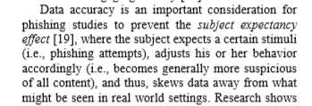

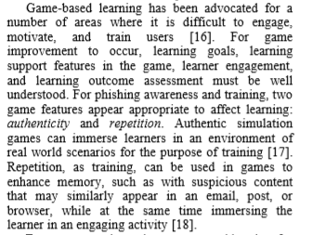

Fig. 1 using some coordinate structures.

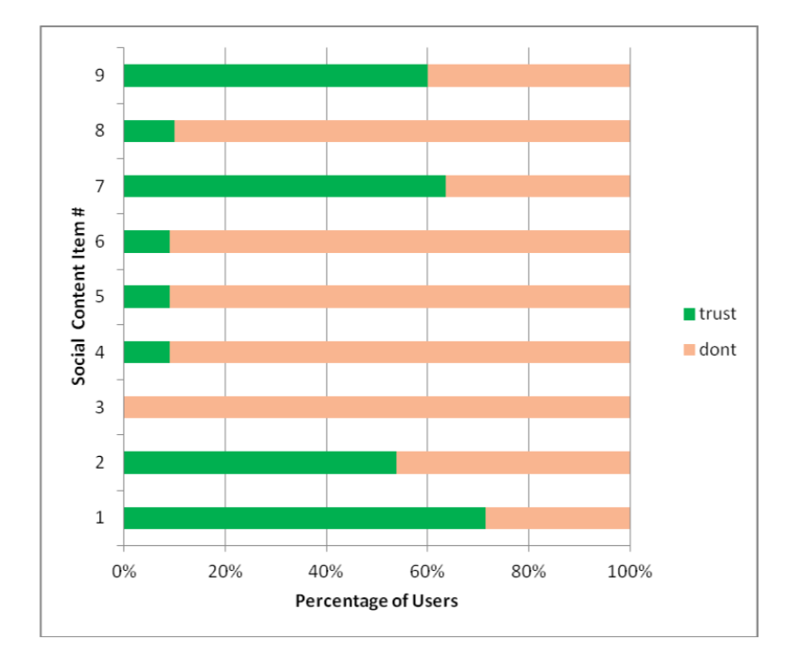

Fig. 2 using accuracy :statistical graphs